**Assignment-4**

Q1. Restaurant Menu

<!DOCTYPE html>

<html>

<head>

  <title>Restaurant Menu</title>

  <style>

    body {

      font-family:'Times New Roman', Times, serif;

      padding: 20px;

      background-color:midnightblue;

    }

    h1 {

      text-align: center;

      color: #fff;

      text-decoration: underline;

    }

    .category {

      background-color: #fff;

      padding: 15px;

      margin-bottom: 20px;

      border-radius: 8px;

      box-shadow: 0 2px 5px rgba(0,0,0,0.1);

    }

    .category h2 {

      border-bottom: 1px solid #ccc;

      padding-bottom: 5px;

      text-align: center;

      text-decoration:underline;

    }

    li {

      margin: 5px 0;

    }

  </style>

</head>

<body>

  <h1>MENU</h1>

  <div class="category">

    <h2>Appetizers</h2>

    <ul>

      <li>Garlic Bread - Rs.259</li>

      <li>Bruschetta - Rs.309</li>

      <li>Stuffed Garlic Bread - Rs.299</li>

    </ul>

  </div>

  <div class="category">

    <h2>Main Courses</h2>

    <ol>

      <li>7 Cheese Pizza - Rs.389</li>

      <li>Pink Sauce Pasta - Rs.359</li>

      <li>White Sauce Pasta - Rs.299</li>

    </ol>

  </div>

  <div class="category">

    <h2>Desserts</h2>

    <ul>

      <li>Chocolate Cake - Rs.99</li>

      <li>Ice Cream Sundae - Rs.69</li>

      <li>Ice Cream Cup - Rs.79</li>

    </ul>

  </div>

  <div class="category">

    <h2>Beverages</h2>

    <ol>

      <li>Coffee - Rs.129</li>

      <li>Tea - Rs.59</li>

      <li>Lemonade - Rs.49</li>

    </ol>

  </div>

</body>

</html>

Output:

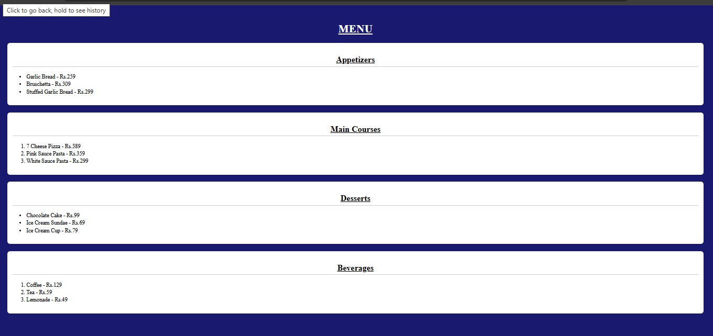

Q2. Tourism Gallery

<!DOCTYPE html>

<html lang="en">

<head>

  <meta charset="UTF-8">

  <title>Tourism Image Gallery</title>

  <style>

    *{

            margin: 0%;

            padding: 0%;

            box-sizing: border-box;

            font-family: 'Times New Roman', Times, serif;

        }

        body{

            background-color: crimson;

        }

        h1{

            text-align: center;

            text-decoration: underline;

        }

        @media (max-width: 600px){

            body{

                background-color: darkmagenta;

            }

        }

        .card-container{

            display: flexbox;

            display: flex;

            justify-content: center;

            margin-top: 100px;

        }

        .card{

            width: 325px;

            background-color: beige;

            border-radius: 8px;

            box-shadow: 0px 2px 4px rgba(0,0,0,0.2);

            margin: 20px;

            overflow: hidden;

        }

        .card img{

            width:100%;

            height: 50%;

        }

        .card-content{

            padding: 16px;

        }

        .card-content h2{

            font-size: 30px;

            margin-bottom: 8px;

        }

        .card-content p{

            color:darkcyan;

            font-size: 20px;

            line-height: 1.3;

        }

  </style>

</head>

<body>

    <h1>Tourism Gallery</h1>

    <div class="card">

            <img src="img4.jpg">

            <div class="card-content">

                <h2>Kangchenjunga Mountains</h2>

                <p>The third highest peak in the world, the majestic Kanchenjunga surroundded by Nepal, Sikkim.</p>

            </div>

        </div>

        <div class="card">

            <img src="img5.jpg">

            <div class="card-content">

                <h2>Bhutan Beauty</h2>

                <p>A land of towering mountainscapes and rich culture, Bhutan is a small, landlocked country situated in the heart of south-central Asia.</p>

            </div>

        </div>

        <div class="card">

            <img src="img6.jpg">

            <div class="card-content">

                <h2>Lhodrak Kharchu Monastery</h2>

                <p>Lhodrak Kharchu Monastery is a Buddhist Nyingmapa Monastery of Jangter Tradition based in Bumthang District Central Bhutan. The monastery overlooks Jakar Dzong and the valley of Jakar town.</p>

            </div>

        </div>

        <div class="card">

            <img src="img7.jpg">

            <div class="card-content">

                <h2>Nepal Culture</h2>

                <p>The culture of Nepal encompasses the various cultures belonging to the 125 distinct ethnic groups present in Nepal. The culture of Nepal is expressed through music and dance; art and craft; folklore; languages and literature; philosophy and religion; festivals and celebration; foods and drinks.</p>

            </div>

        </div>

        <div class="card">

            <img src="img8.jpg">

            <div class="card-content">

                <h2>Himalayas</h2>

                <p>The Himalayas is a mountain range in Asia, separating the plains of the Indian subcontinent from the Tibetan Plateau.It is the highest mounatin peak in the world.</p>

            </div>

        </div>

        <div class="card">

            <img src="img9.jpg">

            <div class="card-content">

                <h2>Bhutan Landscape</h2>

                <p>The Himalayas, or Himalaya is a mountain range in Asia, separating the plains of the Indian subcontinent from the Tibetan Plateau.</p>

            </div>

        </div>

        <div class="card">

            <img src="img10.jpg">

            <div class="card-content">

                <h2>Kathmandu</h2>

                <p>Kathmandu, Nepal's capital, is set in a valley surrounded by the Himalayan mountains. At the heart of the old city’s mazelike alleys is Durbar Square, which becomes frenetic during Indra Jatra, a religious festival featuring masked dances.</p>

            </div>

        </div>

        <div class="card">

            <img src="img11.jpg">

            <div class="card-content">

                <h2>Gangteng Monastery</h2>

                <p>Gangteng Monastery, also known as Gangtey Gonpa or Gangtey Monastery, is a monastery of Nyingmapa school of Tibetan Buddhism, the main seat of the Pema Lingpa tradition, located in the Wangdue Phodrang District in central Bhutan.</p>

            </div>

        </div>

        <div class="card">

            <img src="img12.jpg">

            <div class="card-content">

                <h2>Trekking In Nepal</h2>

                <p>Nepal is a world-renowned trekking destination, offering diverse trails and stunning Himalayan scenery, with popular options including the Everest Base Camp Trek and the Annapurna Circuit.</p>

            </div>

        </div>

  </div>

</body>

</html>

Output:

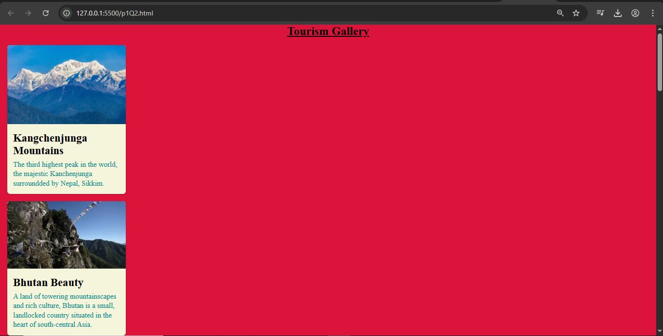

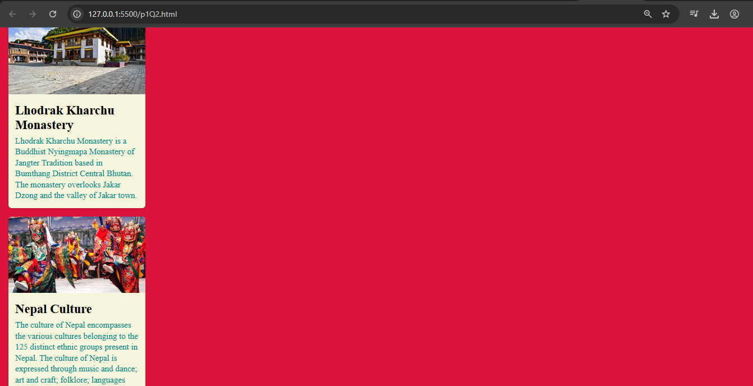

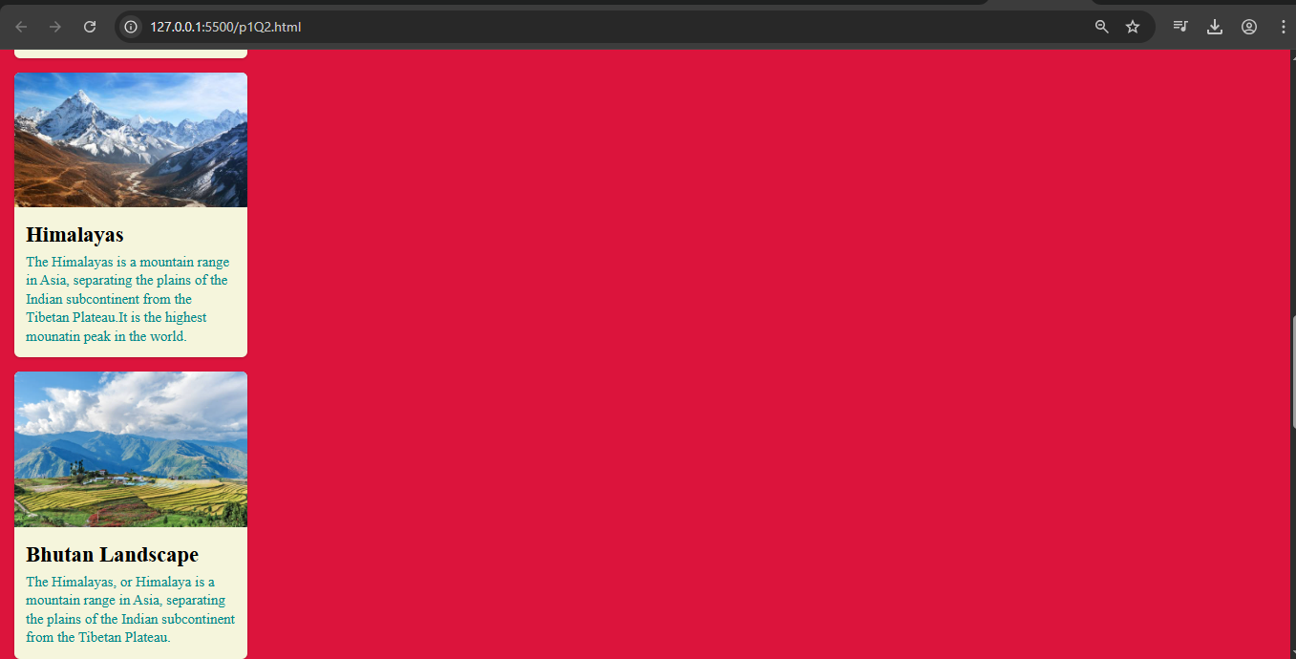

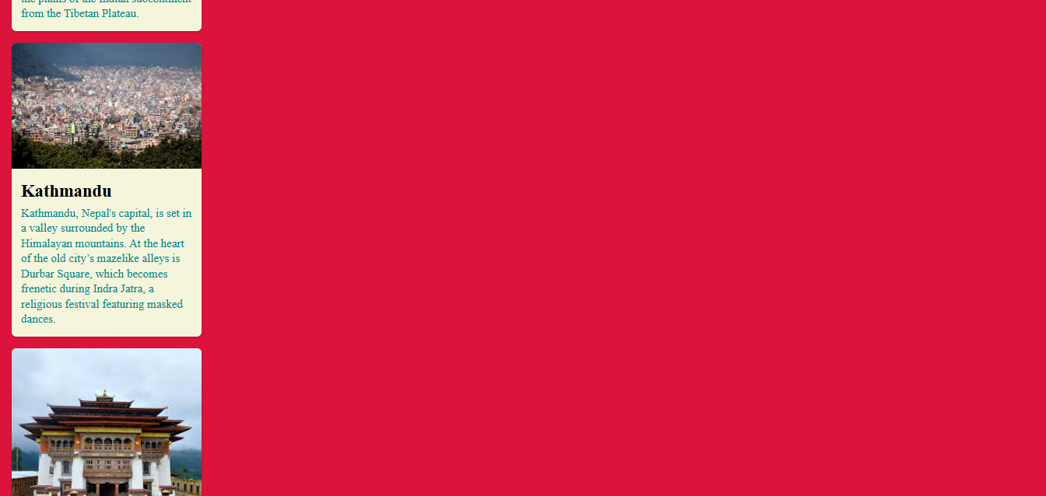

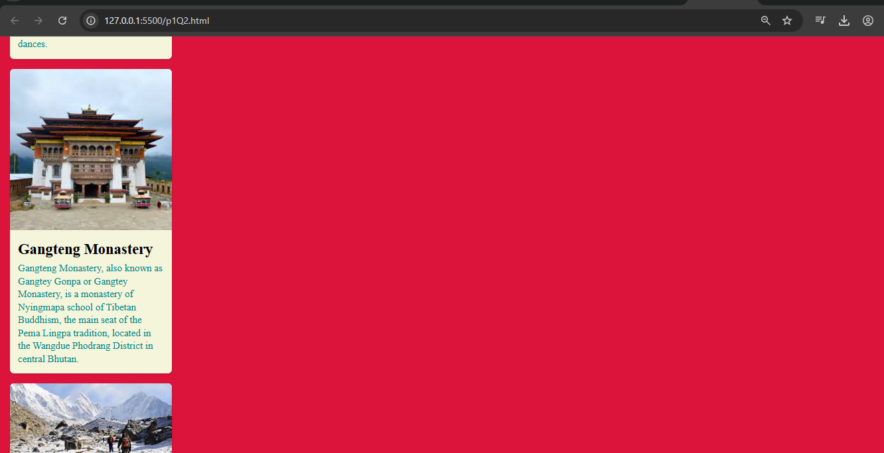

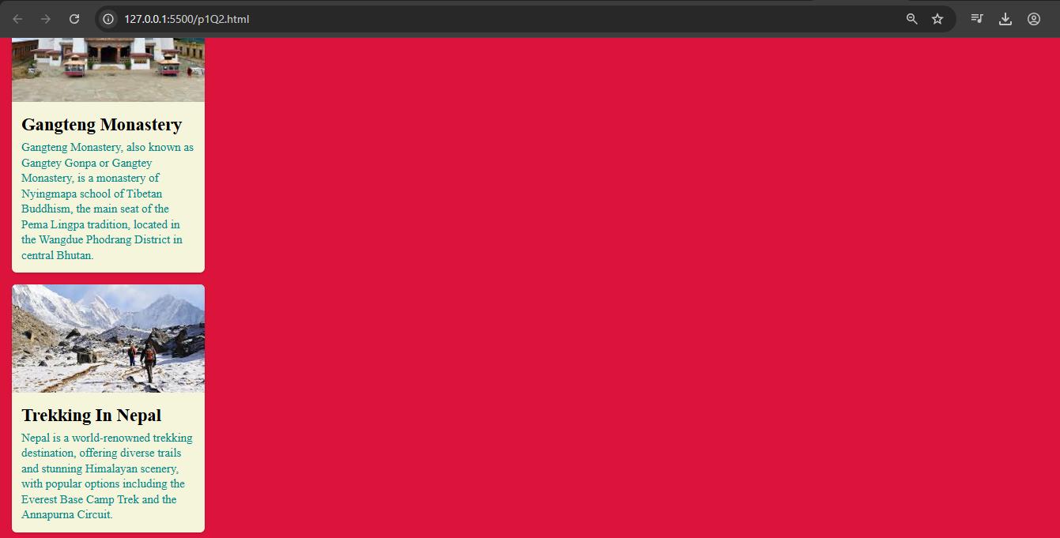

Q3. Navbar with Dropdown

<!DOCTYPE html>

<html lang="en">

<head>

  <meta charset="UTF-8" />

  <title>Flex Navbar with Dropdown</title>

  <style>

    body {

      margin: 0;

      font-family: 'Segoe UI', sans-serif;

      background: #f0f0f0;

    }

    .navbar {

      display: flex;

      background-color: #2c3e50;

      padding: 0 20px;

      align-items: center;

    }

    .navbar a,

    .dropdown-btn {

      color: white;

      padding: 14px 20px;

      text-decoration: none;

      cursor: pointer;

      position: relative;

    }

    .navbar a:hover,

    .dropdown:hover .dropdown-btn {

      background-color: #34495e;

    }

    .dropdown {

      position: relative;

    }

    .dropdown-content {

      display: none;

      position: absolute;

      background-color: #34495e;

      top: 100%;

      left: 0;

      min-width: 160px;

      z-index: 1;

    }

    .dropdown-content a {

      display: block;

      padding: 12px 16px;

      color: white;

      text-decoration: none;

    }

    .dropdown-content a:hover {

      background-color: #3d566e;

    }

    .dropdown:hover .dropdown-content {

      display: block;

    }

    .spacer {

      flex: 1;

    }

  </style>

</head>

<body>

  <div class="navbar">

    <a href="#">Home</a>

    <a href="#">Features</a>

    <div class="dropdown">

      <span class="dropdown-btn">Products ▾</span>

      <div class="dropdown-content">

        <a href="#">Airpods</a>

        <a href="#">Headphones</a>

        <a href="#">Plugins</a>

      </div>

    </div>

    <a href="#">Contact</a>

  </div>

</body>

</html>

Output:

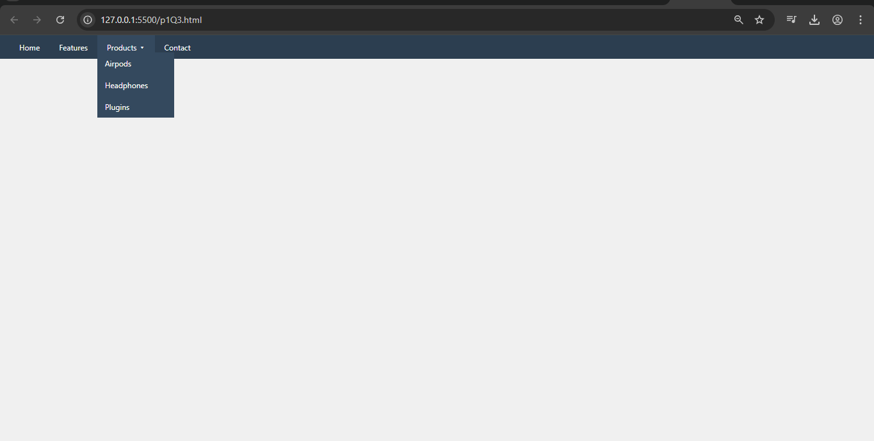

Q4. Form

<!DOCTYPE html>

<html lang="en">

<head>

    <meta charset="UTF-8">

    <meta name="viewport" content="width=device-width, initial-scale=1.0">

    <title>Document</title>

    <style>

        *{

            background-color: bisque;

            font-family: 'Times New Roman', Times, serif;

        }

    </style>

</head>

<body>

    <h1 style="text-align: center;">Registration Form</h1>

    <form>

        Enter name<br>

        <input type="text">

        <br><br>

        Enter mail<br>

        <input type="password">

        <br><br>

        Select gender<br>

        <input type="radio" name="gender" value="Male">Male

        <input type="radio" name="gender" value="Female">Female

        <br><br>

        Select interests<br>

        <input type="checkbox" name="hobby" value="dancing">Dancing

        <input type="checkbox" name="hobby" value="singing">Singing

        <input type="checkbox" name="hobby" value="reading">Reading

        <input type="checkbox" name="hobby" value="cooking">Cooking

        <br><br>

        Enter your preferences<br>

        <input type="textarea">

        <br><br>

        <button type="submit" name="Submit">Submit</button>

        <button type="reset" name="reset">Reset</button>

    </form>

</body>

</html>

Output:

